Nominal Voltage | 51.2V
Rated Capacity | 100AH @0.2C to 40V
Stored energy | 5120Wh
Cycle life@100%DOD | >3000 Cycles@100%DOD  >4000 Cycles@80%DOD  >7000 Cycles@50%DOD
Approx. Weight | 49.5 kg
Internal Resistance | ≤70.0 mΩ
Max. Charge Current | 100 A
Max. Discharge Current | 100 A
Charge Cut-off Voltage | 58.4V
Discharge Cut-Off Voltage | 40V
Dimensions | L483mm×W459mm×H175mm
Series & Parallel Connection | Maxium 16 units in parallel Connection
Operating Temperature Range  Charge  Discharge  Storage | 32°F (0°C) to 113°F (45°C)  -4°F (-20°C) to 140°F (60°C)  -4°F (-20°C) to 140°F (60°C)
Self-Discharge Rate | ≤3%/month @ 25°C
Life Expectancy (years) | 10 years @ 25°C
Communication Port | RS485, RS2332, CAN
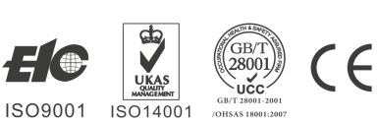
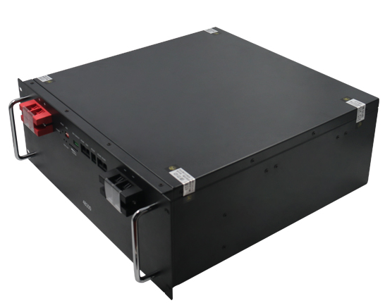

KH-ES48100
www.keheng-battery.com
DATA SHEET
Crafted out of Lithium Iron Phosphate (LiFePO4) technology, this is a battery built to last. With 3,000+ recharge cycles (and up to 7,000 @50%DOD) the 100 Ah provides 5 X the lifespan than your typical SLA battery. Built in smart BMS which can realize real-time monitoring the battery, Compatible with inverters of multiple brands, which can support 16 units parallel connection.
KEHENG 48V 100Ah LiFePO4 LITHIUM BATERY
BATTERY

SPECIFICATIONS
COMPLIED STANDARD
- IEC 62133
- UL 1642
- ISO9001
- ISO14001
- UN38.3
- RoHS
- Over charge protection function
- Over discharge protection function
- Over current protection function
- Short-circuit protection function
- Temperature protection function
- Cell Balance function
- Communicate function
- Alarm function

INTELLIGENT BMS FUNCTION
APPLICATIONS
RESS BESS Back-up system Data center Telecon Energy storage system
Copyright © 2020 KH. All rights reserved.KH Battery Company is not liable for damages that may result from any information provided in or omitted from this publication, under any circumstances. KH Battery Company reserves the right to make adjustments to this publication at any time, without notice or obligation.
1/3
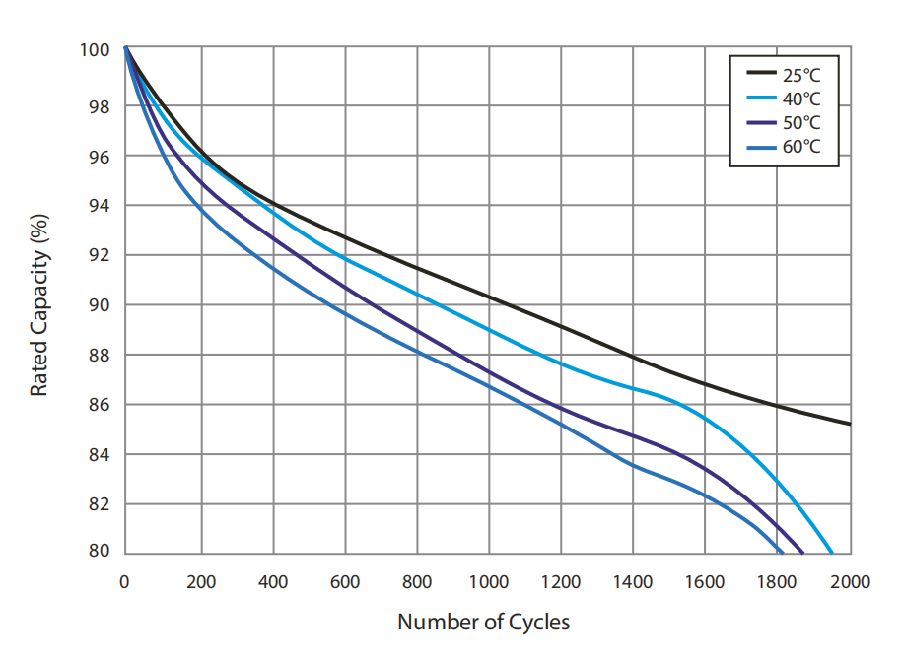
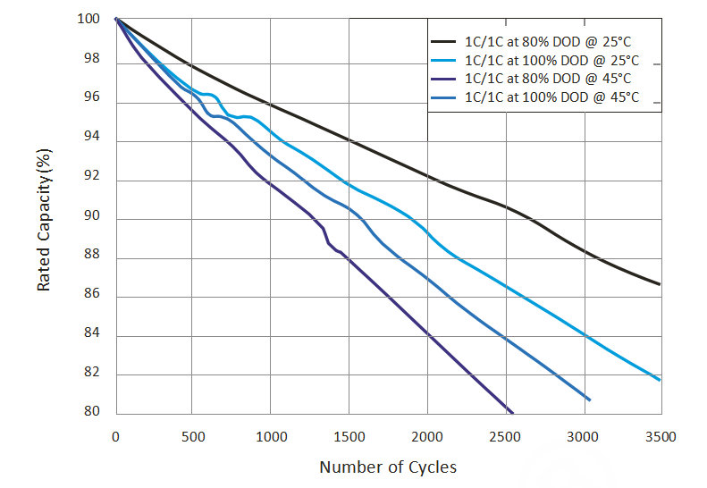
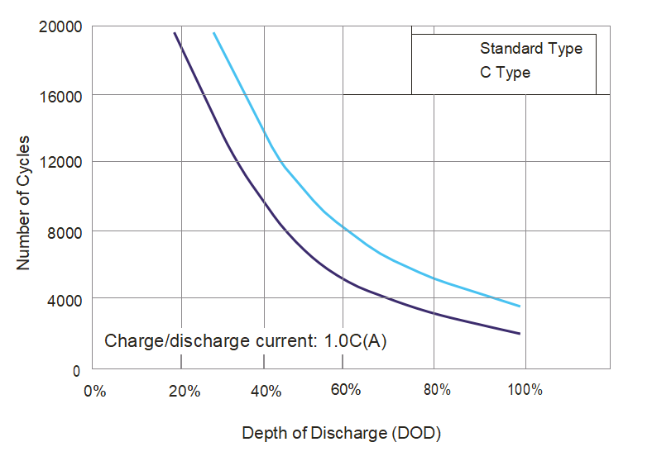
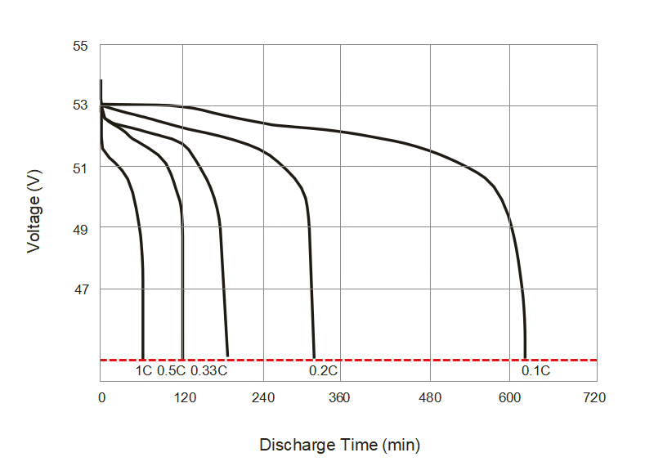
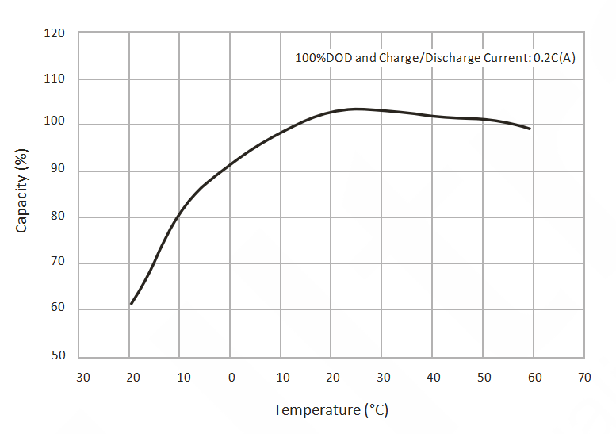
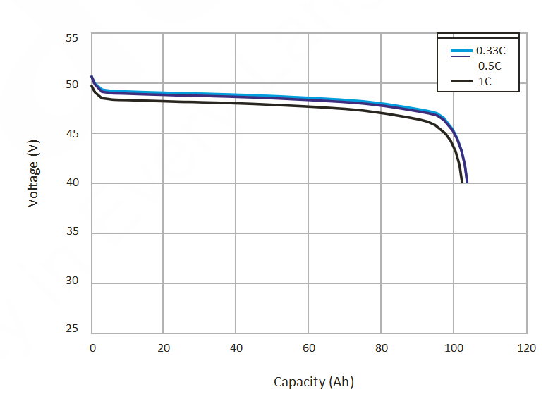

100% DOD Cycle Curves at Different Temperatures 1C Cycle Curves at Different DOD&Temperatures

DOD in Relation to Cycle Life (25°C) Discharge Time in Relation to Discharge Rate (25°C)

Temperature Effect in Relation to Battery Capacity Discharge Capacity in Relation to Discharge Rate
CHARACTERISTIC CURVE

2/3
Copyright © 2020 KH. All rights reserved.KH Battery Company is not liable for damages that may result from any information provided in or omitted from this publication, under any circumstances. KH Battery Company reserves the right to make adjustments to this publication at any time, without notice or obligation.
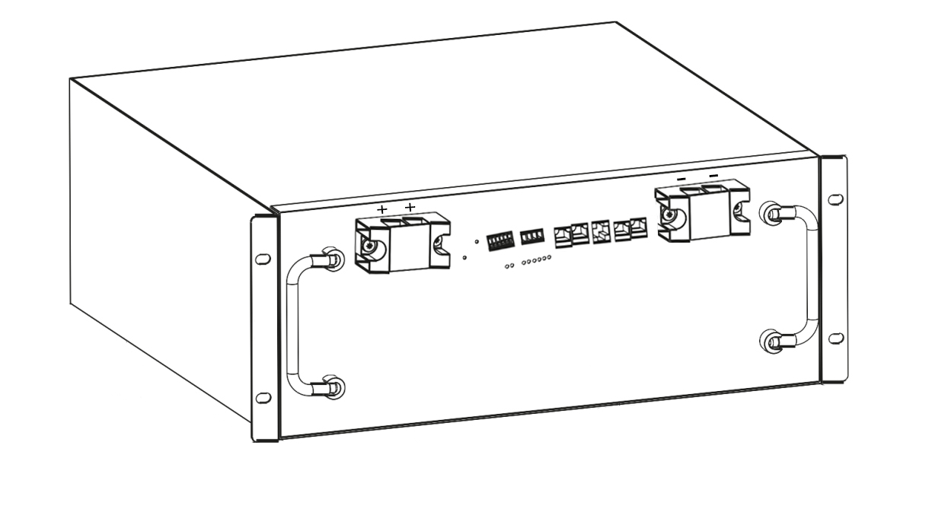
① ② ③ ④
⑤ ⑥⑦ ⑧ ⑨ ⑩ ⑪⑫⑬⑭

①Positive Terminal ②ADD Dialer ③DRY CONTACT ④Negative Terminal
⑤SS Handle ⑥ON/OFF Button ⑦Reset Key ⑧Run Indicator Light
⑨Electricity Volume Indicator ⑩RS485 Port ⑪CAN Port ⑫RS232 Port
⑬RS485 Port ⑭RS485 Port

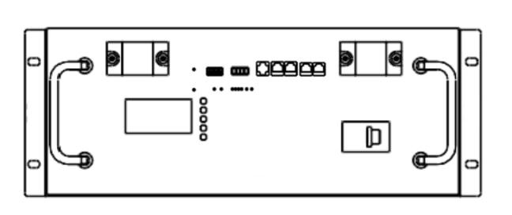
Copyright © 2020 KH. All rights reserved.KH Battery Company is not liable for damages that may result from any information provided in or omitted from this publication, under any circumstances. KH Battery Company reserves the right to make adjustments to this publication at any time, without notice or obligation.
BATTERY DIMENSIONS

Keheng New Energy Technology (shenzhen) Co.,Ltd
Floor 8, D8 Bldg,Lang kou Industrial Park, Long hua District, Shenzhen,china
Tel:+86 0755-21044322 Fax: +86 0755-21044322
Website:www.keheng-battery.com
Email:info@keheng-battery.com
483mm
459mm
175mm

3/3

